|  |  |  |  |  |  |
| --- | --- | --- | --- | --- | --- |
| Compound number | Warhead | Linker motif(s) | Anchor | Predicted lipophilicity  (logD) at pH=7 (OPTIONAL) | Justification |
| 0 | Wogonin | Triazole + Alkyl x 7 + Amide | Pomalidomide | ~3.5 | The starting compound |
| 1 | Substituted pyridopyrimidine (Br, NH₂, F) | PEG-based linker with sulfonamide | Thalidomide analog (CRBN binder) | Approx 2.4 | The warhead is a known kinase-binding motif (CDK9) with high polarity; PEG linker offers flexibility and improves solubility; CRBN-based anchor is a validated E3 ligase recruiter. |
| 2 | Similar to #1 (minor substitutions) | PEG + sulfonamide | Thalidomide-like | Approx. **2.6** | Structural similarity to #1 suggests CDK9 engagement; PEG increases linker length and improves pharmacokinetics; anchor likely ensures E3 ligase recruitment. |
| 3 | 7-azaindole with piperazine | Phenyl–alkyl linker | CRBN binder (glutarimide core) | Approx 3.1 | Azaindole and piperazine are common in kinase inhibitors; hydrophobic linker enhances cell permeability; known CRBN anchor provides reliable degradation potential. |
| 4 | 7-azaindole with piperazine | Triazole-ether linker | Glutarimide anchor (CRBN) | Approx 4.8 | Warhead resembles selective kinase scaffolds with polar functionalities; rigid linker may enhance selectivity; glutarimide anchor ensures CRBN recruitment. |
| 5 | Aminopyrimidine–morpholine | Piperazine + amide | CRBN-binding glutarimide | Approx 3.8 | Warhead includes CDK9-active moieties; linker provides H-bonding potential and conformational flexibility; anchor supports efficient ternary complex formation. |

**Please paste the chemical formula(e) of at least one additional PROTAC candidate below.**

1

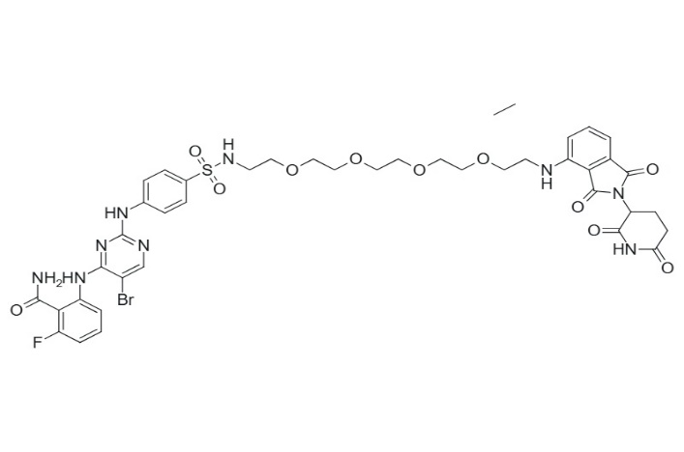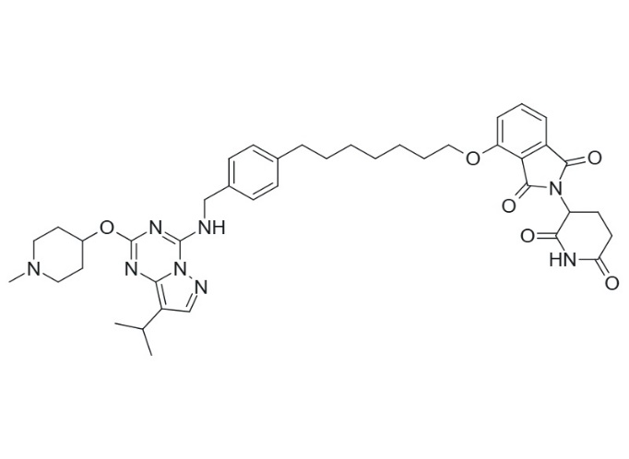**3**

**2**

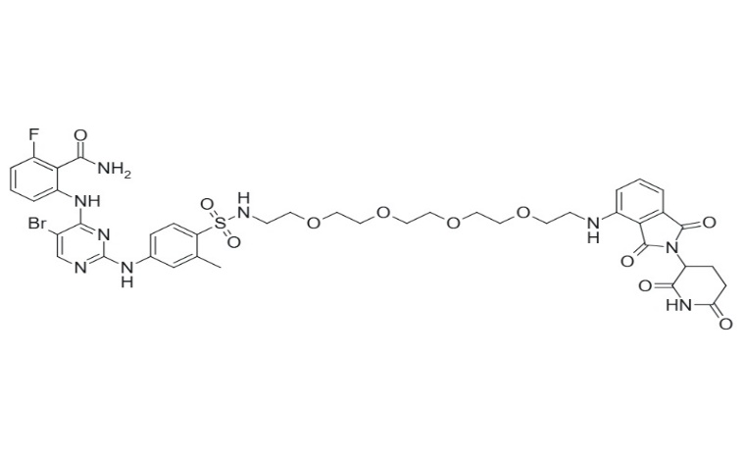 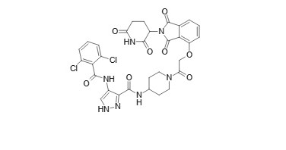 **4**

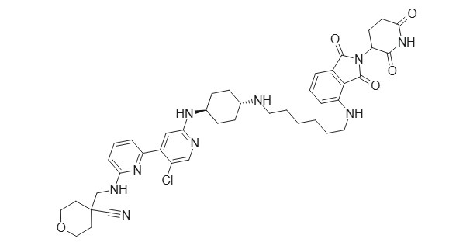**5**